Report on Geyser Cells (Gen-II)
Purpose: evaluate operating regimes and branch asymmetry. Establish standard reported parameters and standard current/voltage windows for future cell sorting, comparison, and scale-up.

Executive Summary
The cell does not behave like a symmetric EDLC. Based on the stabilized cyclic voltammetry (CV) loops and the constant-current cycling traces, it behaves as an asymmetric pseudocapacitor / hybrid cell. The reverse-scan and discharge branches are comparatively flatter and cleaner, while the forward-scan and charge branches rise progressively and accelerate in the upper-voltage region. For standard parameter extraction in non-zinc mode, the discharge branch is therefore the more reliable basis.
Some energy-efficiency penalties are characteristic of this asymmetric pseudocapacitive / hybrid behavior, but low energy efficiency is not a fixed inherent destiny of chemistry. The full 4.5 A terminal cycling in the nominal 0.85–1.70 V range gives approximately 86.96% energy efficiency, whereas the common overlapped core window (0.90 V to 1.65 V) that both branches traverse well gives approximately 94.90% energy efficiency. This indicates that most of the loss is associated with terminal hysteresis, current-reversal IR loss, and the upper charge window rather than uniformly poor behavior across the whole cell.
A neutral current derived from the raw data falls near 3.3–3.5 A, depending on the capacitance definition used. The proposed standard current of 20 mA·cm⁻² over 173.24 cm², equal to 3.465 A, lies directly inside this range and is therefore technically well aligned with the measured non-zinc-mode behavior.

Analysis Basis and Definitions
The stabilized CV interpretation was based on 4 cycles. The steady-state constant-current cycling analysis is based on 20 cycles. For constant-current cycling, window tables therefore report the effective terminal-accessed spans inside the nominal 0.85–1.70 V non-zinc window.
- Capacity, Ah: $Q = \int{I} dt$
- Energy, Wh: $E = \int{V} I dt$
- Capacitance, F: $C = I \frac{∆t}{∆V}= 3600\frac{Q}{ΔV}$
- Coulombic Efficiency, %: $η_{Q} =\frac{Q_{discharge}}{Q_{charge}}$
- Energy Efficiency, %: $η_{E} =\frac{E_{discharge}}{E_{charge}}$
- Voltage Efficiency, %: $η_{V} =\frac{η_{E}}{η_{Q}}$
- Current Reversal ESR, mΩ: $ESR = 1000 ×\frac{ΔV}{\left|I_{charge}\right|+ \left|I_{discharge}\right|}$
- Current equivalent to CV scan, A: $I_{std} ≈ C × ν$
Item | Value
CV protocol | 0.50 → 1.72 → 0.50 V at 10 mV/s, repeated 4 cycles
CC cycling protocol | 20 cycles at ±4.5 A between nominal 0.85 and 1.70 V

1) Regime Map from Cyclic Voltammetry (CV)
Using stabilized forward and reverse CV loops only, the charge and discharge behavior is not symmetric. See Figure 1.
Charge branch (0.50 → 1.72 V): the low-voltage region up to approximately 0.70 V is EDLC-like or mostly non-faradaic, the region from approximately 0.70 to 1.45 V is hybrid / pseudocapacitive-dominant, and the region from approximately 1.45 to 1.72 V is faradaic-dominant.
Discharge branch (1.72 → 0.50 V): the immediate upper segment from approximately 1.72 down to 1.65 V is a turnaround / stored-polarization relaxation region; the broad segment from approximately 1.65 down to 0.60 V is a quasi-capacitive / hybrid plateau; and the lower segment from approximately 0.60 down to 0.50 V is a lower-voltage tail / roll-off.
This asymmetry is the main reason the discharge branch is the better basis for standard non-zinc parameter extraction. The forward scan and charge branch increasingly include upper-window faradaic amplification and should not be treated as if the device were a symmetric supercapacitor.
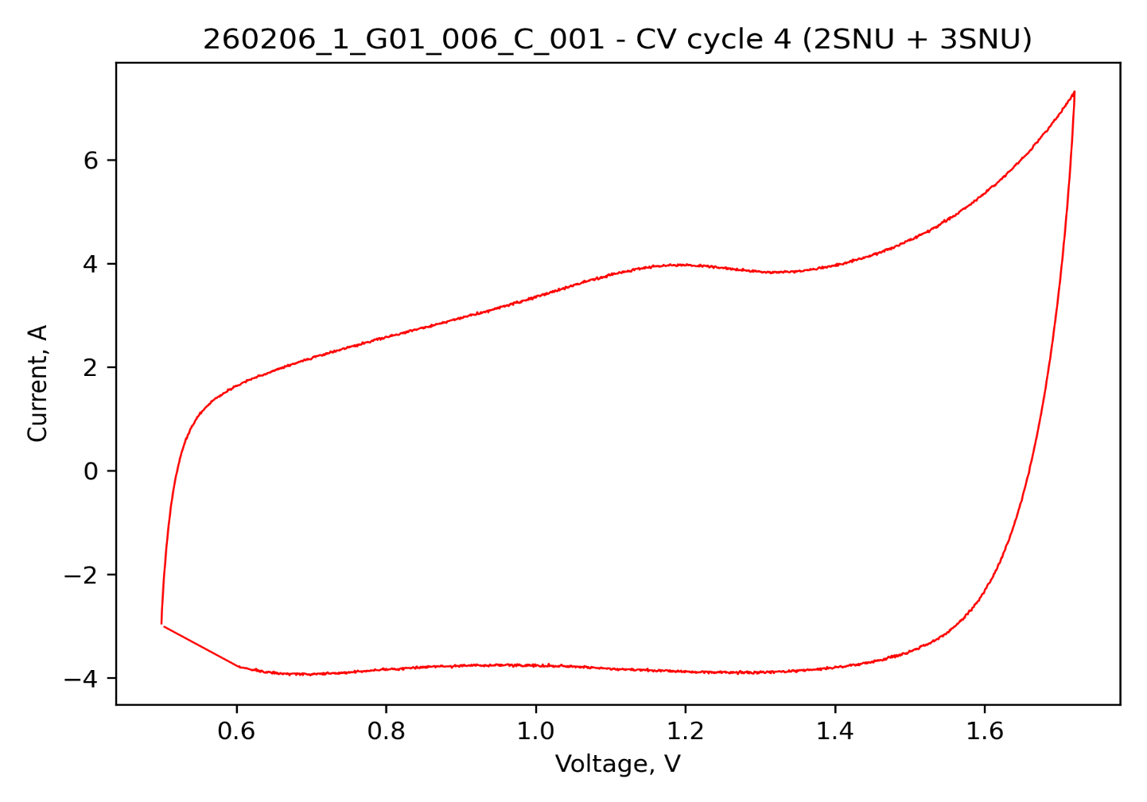
Figure 1: Characteristic Cyclic Voltammetry of Geyser Cells.
Branch | Voltage range | Interpretation
Forward scan (charge-like) | 0.50–0.70 V | Predominantly EDLC-like startup / mostly non-faradaic
Forward scan (charge-like) | 0.70–1.45 V | Hybrid / pseudocapacitive-dominant
Forward scan (charge-like) | 1.45–1.72 V | Faradaic-dominant upper region
Reverse scan (discharge-like) | 1.72–1.65 V | Turnaround / stored polarization
Reverse scan (discharge-like) | 1.65–0.60 V | Broad quasi-capacitive / hybrid plateau
Reverse scan (discharge-like) | 0.60–0.50 V | Lower-voltage roll-off
The forward and reverse scans confirm that the full-cell behavior is asymmetric even when evaluated continuously over the entire 0.50–1.72 V sweep.
Forward scan (0.50 → 1.72 V):
Window | Ah | Wh | Apparent C (F)
0.50–0.70 V | 0.00718 | 0.00458 | 129.2
0.70–1.45 V | 0.07068 | 0.07855 | 339.3
1.45–1.72 V | 0.04095 | 0.06543 | 546.1
Full 0.50–1.72 V | 0.11881 | 0.14856 | 350.6
Reverse scan (1.72 → 0.50 V):
Window | Ah | Wh | Apparent C (F)
1.72–1.45 V | 0.01056 | 0.01535 | 140.9
1.45–0.70 V | 0.08038 | 0.08636 | 385.8
0.70–0.50 V | 0.02011 | 0.01204 | 362.1
Full 1.72–0.50 V | 0.11106 | 0.11375 | 327.7
The full-loop CV coulombic efficiency is approximately 93.3% and the full-loop CV energy efficiency is approximately 76.6%. The dynamic CV values are lower than the steady constant-current efficiencies because the CV trajectory continuously includes polarization, turnaround effects, and upper-window charge amplification.
This reinforces why non-zinc sorting parameters should be grounded primarily in the discharge branch and in a well-defined constant-current standard test.

2) Constant Current (CC) Cycling Map
These values confirm that the nominal non-zinc-mode cycle is not energy-symmetric at the terminals. Charge throughput exceeds recovered discharge throughput, and the disparity is more pronounced in energy than in charge, which is consistent with polarization and hysteresis rather than only irreversible charge loss.
Metric | Value
Charge capacity | 0.07697 ± 0.00149 Ah
Discharge capacity | 0.07371 ± 0.00109 Ah
Charge energy | 0.10442 ± 0.00224 Wh
Discharge energy | 0.09084 ± 0.00126 Wh
Coulombic efficiency | 95.78 ± 0.43 %
Energy efficiency | 87.01 ± 0.65 %
Voltage efficiency | 90.84 ± 0.28 %
Charge ESR | 5.31 ± 0.11 mΩ
Discharge ESR | 5.24 ± 0.10 mΩ
Recommended single ESR | 5.28 mΩ
The following tables decompose the steady-state ±4.5 A non-zinc cycles into low, mid, and upper windows inside the nominal 0.85–1.70 V operating range. The spans are the effective terminal-accessed spans after accounting for current-reversal jumps.
Charge branch at 4.5 A:
Window | Effective span used | Ah | Wh | C (F)
Low | 0.897–1.150 | 0.01793 | 0.01862 | 255.3
Mid | 1.150–1.450 | 0.02766 | 0.03606 | 332.0
Upper | 1.450–1.700 | 0.03133 | 0.04971 | 451.1
Full | 0.897–1.700 | 0.07693 | 0.10439 | 344.9
Discharge branch at 4.5 A:
Window | Effective span used | Ah | Wh | C (F)
Upper | 1.652–1.450 | 0.01569 | 0.02421 | 279.4
Mid | 1.450–1.150 | 0.02895 | 0.03761 | 347.4
Low | 1.150–0.850 | 0.02896 | 0.02891 | 347.6
Full | 1.652–0.850 | 0.07360 | 0.09073 | 330.3
The key interpretation is that the upper window stores the largest fraction of charged energy, but it does not return energy proportionally on discharge. In the CC cycles, the upper charge window contributes roughly 47.6% of total charged energy, while the upper discharge window returns only about 26.7% of total discharged energy. The mid and lower windows are more important contributors to recovered non-zinc energy for the discharge cycle.
The contrast between full-cycle and common-window performance is central to interpreting this technology. The common-window energy efficiency is approximately 94.90%, which is much higher than the approximately 86.96% full-cycle terminal energy efficiency. This shows that chemistry is not uniformly inefficient. Instead, the main losses are concentrated in terminal hysteresis, the current-reversal IR jump, and the upper charge window.
For development discussions, this distinction is important: some energy-efficiency penalty is characteristic of the asymmetric pseudocapacitive / hybrid behavior, but low energy efficiency is not a fixed inherent destiny of the chemistry.
Item | Value
Charge, common window (0.90–1.65 V) | 0.06881 Ah | 0.09082 Wh
Discharge, common window (1.65–0.90 V) | 0.06844 Ah | 0.08617 Wh
Common-window coulombic efficiency | 99.46 ± 0.16 %
Common-window energy efficiency | 94.90 ± 0.40 %
Common-window voltage efficiency | 95.41 ± 0.25 %

3) Energy Map by Voltage Window
Charging and discharge energy are not mirror images for this cell. More watt-hours are inserted during charging in the upper-voltage region (1.45 – 1.72V) because energy weighting increases with voltage and the upper branch shows stronger pseudocapacitive / faradaic amplification. On discharge, the recoverable watt-hours are distributed more strongly across the mid and lower windows (1.65-0.60 V) because discharge begins after an IR drop and then proceeds through a flatter plateau.
This means that pushing farther into the upper-voltage region can increase charged watt-hours, but it also increases the risk of losing energy efficiency through branch hysteresis and current-reversal IR loss. For non-zinc-mode comparison work, the useful engineering question is therefore not simply how much energy can be inserted, but how much energy can be recovered consistently and repeatably.
A good balance window is about 0.85–1.55 V nominal for non-zinc-mode comparison work. A more conservative, higher-recovery / higher-repeatability window is 0.85–1.50 V. The normal window of 0.85–1.70 V should not be used as the primary comparison window if the goal is recoverable Wh rather than maximum inserted Wh. The most reliable way to judge the tradeoff is to look at the marginal return from each added upper-voltage band in the steady 4.5 A cycling data. When the upper region is split into 50 mV slices, the additional stored energy on charge and the additional recovered energy on discharge behave:
Window, V | Charge, Wh | Discharge, Wh | Recovery, %
1.45-1.50 | 0.00762 | 0.00686 | 90
1.50-1.55 | 0.00836 | 0.00674 | 80.7
1.55-1.60 | 0.00937 | 0.00637 | 68.1
1.60-1.65 | 0.01082 | 0.00418 | 38.7
1.65-1.70 | 0.01351 | 0.00004 | 0.3
A second useful way to see it is cumulative recovered discharge energy. Relative to the full measured non-zinc discharge energy of about 0.09084 Wh:
- up to 1.45 V, you already retain about 73%
- up to 1.55 V, you retain about 88%
- up to 1.60 V, you retain about 95%
- up to 1.65 V, you are essentially at the full discharge value
But the cost of going higher rises sharply. In particular:
- moving from 1.45 → 1.55 V adds about 0.0136 Wh of recovered discharge energy, which is still worthwhile
- moving from 1.55 → 1.65 V adds only about 0.0106 Wh recovered, but costs about 0.0202 Wh extra on charge
- moving from 1.65 → 1.70 V is extremely poor for recoverable-energy-based comparison
So, the practical choices are:
Best balanced comparison window: 0.85–1.55 V
This is the best compromise between added Wh and recovered Wh.
Best conservative / repeatable comparison window: 0.85–1.50 V
For tighter non-zinc ranking with less influence from upper-window asymmetry.
Best maximum-energy characterization window: 0.85–1.70 V
Intentional probe into the high-energy end, not for a cleanest comparison metric.

4) Assessment of Standard Current for Future Non-Zinc Sorting
In practical terms, 3.465 A is a good choice for the 0.85–1.70 V non-zinc mode used for sorting, comparison, and scale-up. It is close enough to the CV-equivalent neutral current to preserve continuity with the observed branch behavior, yet low enough to avoid over-emphasizing the upper-window faradaic acceleration that becomes more visible at 4.5 A.
If the cell does not plateau or takes a long time to increase voltage when pushed deeper into the 1.70–1.80 V purely faradaic region at approximately 3.3–3.5 A, that behavior is consistent with charge being consumed by ongoing faradaic storage rather than only surface charging. This does not argue against 3.465 A as the non-zinc standard current. Instead, it supports keeping the non-zinc sorting window separate from the deeper faradaic window.
Basis | Input | Equivalent current
Discharge usable capacitance basis | C ≈ 330.3 F | I ≈ C × ν = 3.30 A at 10 mV/s
Charge/discharge mid-window basis | C ≈ 344–345 F | I ≈ C × ν = 3.45 A at 10 mV/s
Active-area criterion | 20 mA·cm⁻² × 173.24 cm² | I = 3.465 A
Primary standard current for non-zinc sorting, comparison, and scale-up: 3.465 A.
Lower-stress energy or leakage characterization current, when needed: 2.5 A.

5) Recommended Standard Reported Parameters
For this chemistry, the most robust standardization strategy is to emphasize discharge-based non-zinc metrics, because the discharge branch is more stable and more representative of recovered usable performance. Charge-side values remain important, but they should be interpreted primarily as insertion and hysteresis indicators rather than as direct surrogates for recovered capability.
Parameter | Recommended reporting basis
ESR 10ms and ESR 1s | Upper and lower current-reversal ESR; report the combined value as the primary ESR metric
Discharge capacitance | Window-defined discharge capacitance in the standard non-zinc window
Discharge capacity (Ah) | Recovered ampere-hours in the standard non-zinc window
Discharge energy (Wh) | Recovered watt-hours in the standard non-zinc window
Full window η_{Q} and η_{E} | Terminal efficiencies over the actual full non-zinc cycle
Common window η_{Q} and η_{E} | Core-window efficiencies after excluding reversal tails
Window split | Low / mid / upper contributions to Ah and Wh on both charge and discharge
Asymmetry note | Brief qualitative interpretation of forward- vs reverse-branch behavior
In summary, the upper window is where energy is gained, but it is also where energy efficiency is most strongly penalized. For non-zinc cell sorting and scale-up, the technical sound approach is to use a standard current near 3.465 A, define the primary ESR metrics, and report discharge-based C / Ah / Wh together with both full-window and common-window efficiencies. For non-zinc-mode sorting and comparison, a nominal window near 0.85–1.55 V at 20 mA·cm⁻² appears to give the best balance between energy inserted and energy recoverable from the cell. Above about 1.55 V, the marginal recovered energy falls off progressively, and above about 1.65 V the added charged energy is no longer recovered efficiently enough for use as a primary comparison window. Hence, according to the analysis adopting 3.465 A current and a nominal voltage range of 0.825 V to 1.65 V instead of the current 0.85 V to 1.7 V range will keep the same energy as the current Gen-II cells but with higher efficiency (>95%) and comparable parameters across different batches.

Appendix A
The cell used for this analysis is a good representative (95th percentile) for the production at Geyser, and has the following characteristics:
Index | 260206_GO_006
Minus | M68
Plus | M34
Cell_ratio | 0.689933259
Average_ratio | 0.71572071
Deviation_% | -3.603004682
Plus_m, g | 2.29722222
Minus_m, g | 3.32962963
Cell_mass, g | 34.39
Resistance, mohms | 5.199
Specific Discharge Energy, Wh/g | 0.0267297

